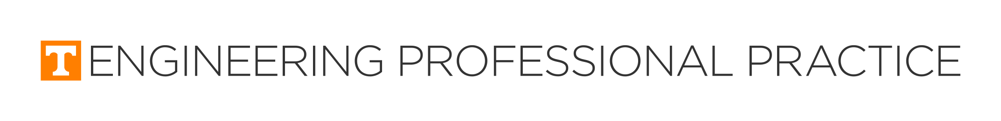

Student Work Report
Please answer every question.
The following information is required to be provided to our office and your department. We need you to complete and submit this form two weeks before your last day of work.
There are two sections of the form. The first section is confidential. It will be retained in the co-op office with your records and academic materials. The second section may be made public. Copies may be made and sent to your department head and academic advisor, and a copy could be made available in the office. Other prospective co-ops may use your information to help them decide on whether or not to select a particular company.
By submitting this form, you agree that the information you provide is an accurate and accountable description of your last work assignment. If you have any problems or questions, please contact the office at (865) 974-5323 or via email at coop@utk.edu.
Section 1. Student Work Report - Confidential Section
1. Name:

2. UT Student ID:

3. UT E-mail address:

4. Current Work Semester (Fall, Spring, Summer):

5. Year:

6. Major:

7. Supervisor's name:

8. Supervisor's title and company name:

9. Employer's co-op representative:

10. Was the supervisor's evaluation discussed with you?
Yes
No

11. If you answered yes to the previous question, who did you discuss your evaluation with?

12. Did you discuss your views regarding this work term with your supervisor?
Yes
No

13. If you answered yes to the previous question explain how your views were accepted:

14. Overall, how do you rate this work term?
Outstanding
Very Good
Good
Marginal
Unsatisfactory

15. How do you rate YOUR overall effort for this work term?
Outstanding
Very Good
Good
Marginal
Unsatisfactory

16. What could have been done to improve this assignment?

17. Would you recommend this employer for other students in YOUR major?
Yes
No

18. Would you recommend this employer for students in OTHER majors?
Yes
No

19. What other major(s) would you recommend this employer to?
Aerospace
Biomedical
Biosystems
Civil
Chemical
Computer Engineering
Computer Science
Electrical
Industrial
Materials Science
Mechanical
Nuclear

20. Do you anticipate any changes in your academic or personal situation that might affect your future work assignments?
Yes
No

21. When is your next assignment (semester and year)?

22. When is your expected graduation (semester and year)?

Section 2. Student Work Report - Public Information Section.
This information may be shared with others outside of our office.

23. I agree that this information may be shared with others in order to promote the co-op program to prospective students and employers:
Yes
No

24. In detail, describe what department you worked in, and what your responsibilities and projects were with relationship to the department's operations:

25. Were opportunities for training available?
Yes
No

26. If the answer to the previous questions about training opportunities is YES, please describe your training experience:

27. Please describe any new technical skills you learned such as software packages, CAD, reading P&ID drawings, lab equipment, etc.:

28. If you participated in company meetings, what did you learn from them?
29. Describe one challenge that you had to overcome during this assignment, how you solved it and the key lesson you learned:

30. What are some specific observations you have (good or bad) concerning this work assignment?

31. What could have been done to improve this assignment?

32. Describe one thing you wish you had known before your first day of work in this assignment:

33. What brief advice would you give a co-op applicant considering this employer?

34. Describe the most valuable benefit you received by accepting your co-op or internship:

This concludes the Student Work Report. Thank you for taking the time to provide this important feedback to us!

